More than Content: Activating Reading(s) to Teach Writing Lessons
FYE Orientation 2021
Hannah Rule, Associate Professor of English, Rhet/Comp

1) Quickwrite/Think (5 mins): Why do we have students “do readings” in first-year English? What purposes do readings serve? What does reading have to do with writing? How can our work with "a reading" help students learn more about writing?

Activity: Think—Pair—Share

2) Whole Group Share
- What can we do with reading(s)?
- Mindy Rogers, “My Father’s English”—how can it mentor/guide students’ writing?
- What challenges or problems do you see/anticipate in students’ writing and how could work with reading(s) help?

3) Two Things

- Approach Readings as “Mentor Texts,” as Writing Mentors
Mike Bunn, “How to Read Like a Writer” (on 101 schedule)
On “Mentor Texts”

“Teaching Students to Read like Writers Promotes Writing Growth”— Diane Lapp, Douglas Fisher, and Nancy Frey, 2015
“When engaging with an exciting novel, a motivating poem, or an interesting informational article, do you ever find that in addition to being enthralled by the content you often return to the text to muse about the craft used by the author to convey the information or tell the story? This happens to us often, and these are always the pieces we find most interesting; they are often the ones we encourage others to read. These are the pieces that intrigue us because of the information or story being shared and the author’s way of relaying it.

As skilled readers, we all read like writers who in turn consider the crafting techniques used by other writers. We like to look at the language and consider why the author used particular words in particular ways. We consider the facts being shared or the way the story unfolds. We deliberate on the clues we’ve been given to guess the ending and wonder about what details and clues were left out. We reread to visualize the images the author is painting for us and just how this is affecting our interpretation. We like to consider the types of sentences that are being used; are they short and choppy or long and flowing? It’s interesting to think about how different sentence constructions influence understanding and emotion. So too is it interesting to consider punctuation. How are dashes, colons, and periods used to create connections between and among ideas?

Teaching students to discern the author’s intentionality in crafting a text supports their development as both readers and writers. At the conclusion of reading, students who are becoming good writers should be able to explain what the text says as well as how the story was told or the information was conveyed. They should consider whether they are compelled to invite others to read it, and if not—why not? An examination of the how of the text supports writers having a tool bag full of ways to share their own ideas”

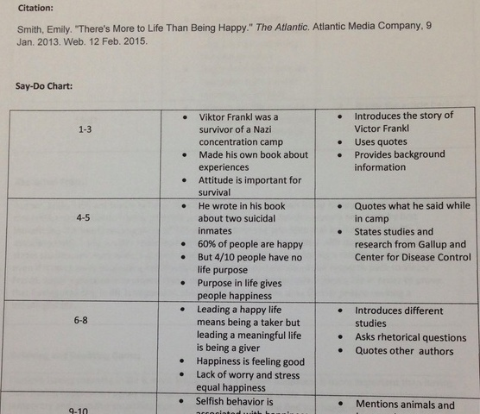
- Says/Does
- A practice that helps reader-writers discern between content and constructedness/craft, or what a text says and how it chooses to say it
- What it Says/What it Does Chart and Instructions
- Variation: Says/Does/Because

Assumptions:
- Approaching text rhetorically = purposeful, situated, constructed
- Question of genre/mode—aesthetic / rhetoric
  - Is a poem rhetorical like a letter to the editor or a 101 synthesis essay? No. But! Each is in different ways purposeful/motivated, situated, constructed
    - Mentor text methods typically emphasize mentors in the same genre; however, there are things a poem can teach us relevant to craft in a persuasive or academic genre
    - Crossing genre boundaries too demonstrates the elusiveness of intentionality and textual control, the interpretive wiggle of choice and effect

